JENKINS ASSIGNMENT
- Build and Deploy a Simple App using Jenkins

Step 1: Install Required Plugins
1️. Open Jenkins Dashboard → Manage Jenkins → Manage Plugins.
2️. Install the following plugins:
- Pipeline
- Git Plugin
- Docker Pipeline Plugin (if using Docker)

Step 2: Create a New Jenkins Pipeline Job
1️. In Jenkins, click New Item → Pipeline → Give it a name → Click OK.
2️. Scroll down to the Pipeline section and select Pipeline script from SCM.
3️. In the SCM field, select Git, then enter your GitHub repository URL.
4️. In the Branch Specifier, enter */main or */master.
5️. In the Script Path, enter Jenkinsfile (which we will create in the next step).
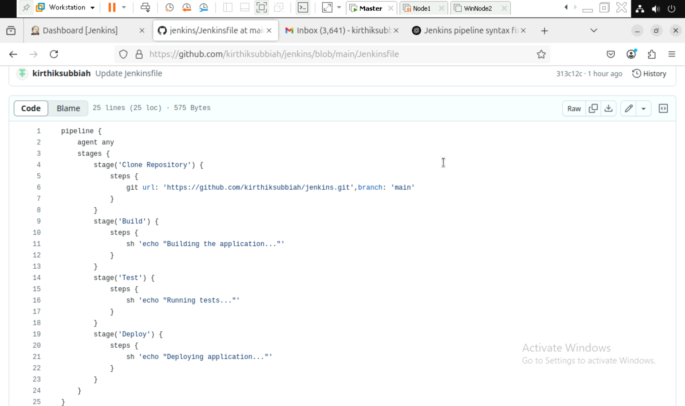

Build History:
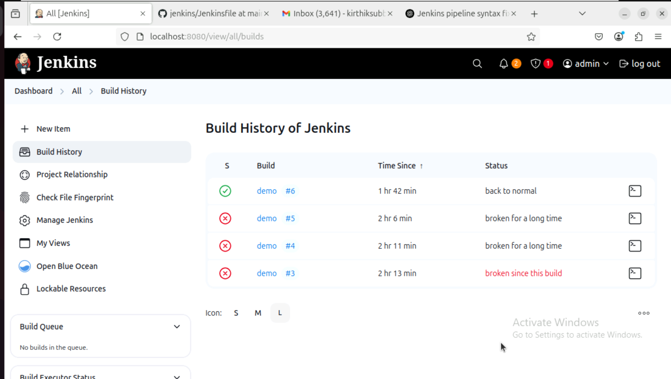
Status of Each stages of the pipeline:
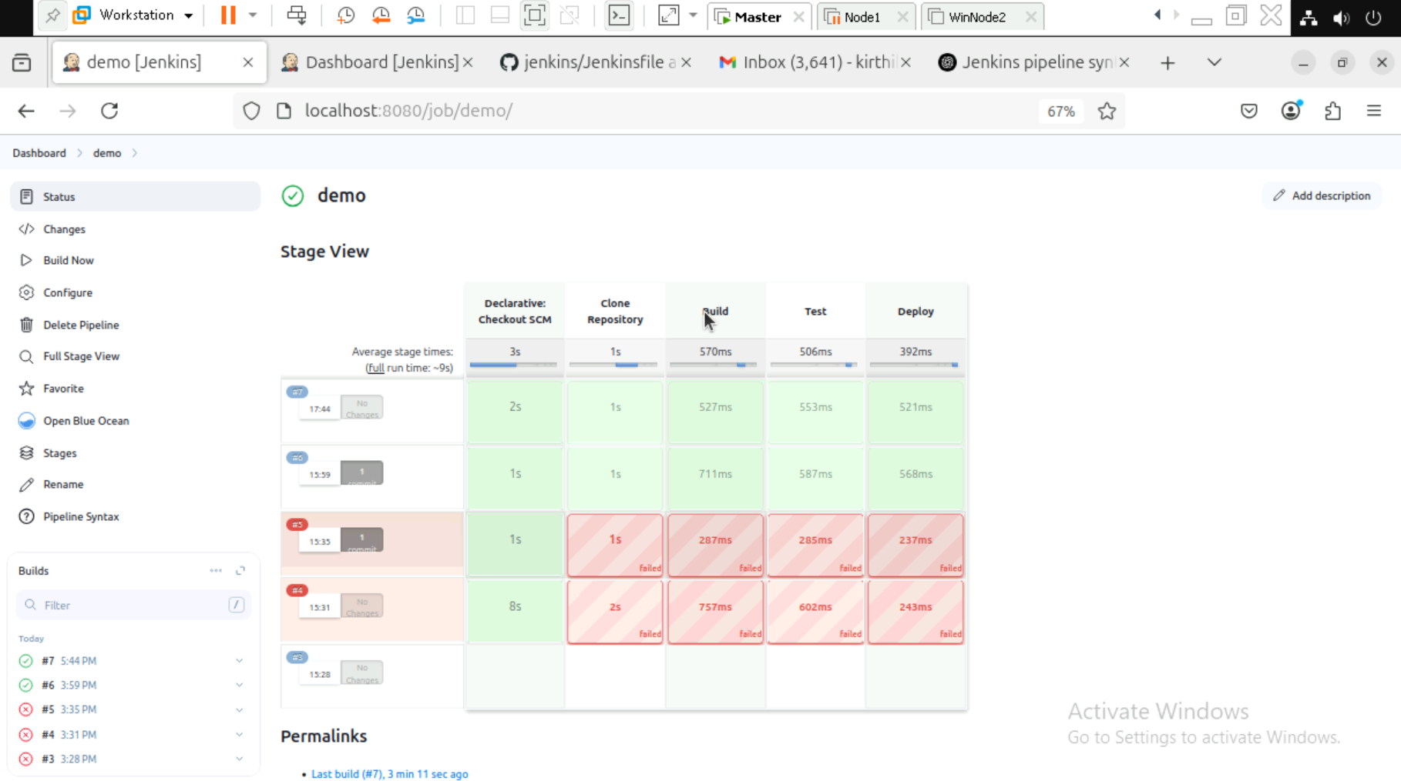

Workspace:
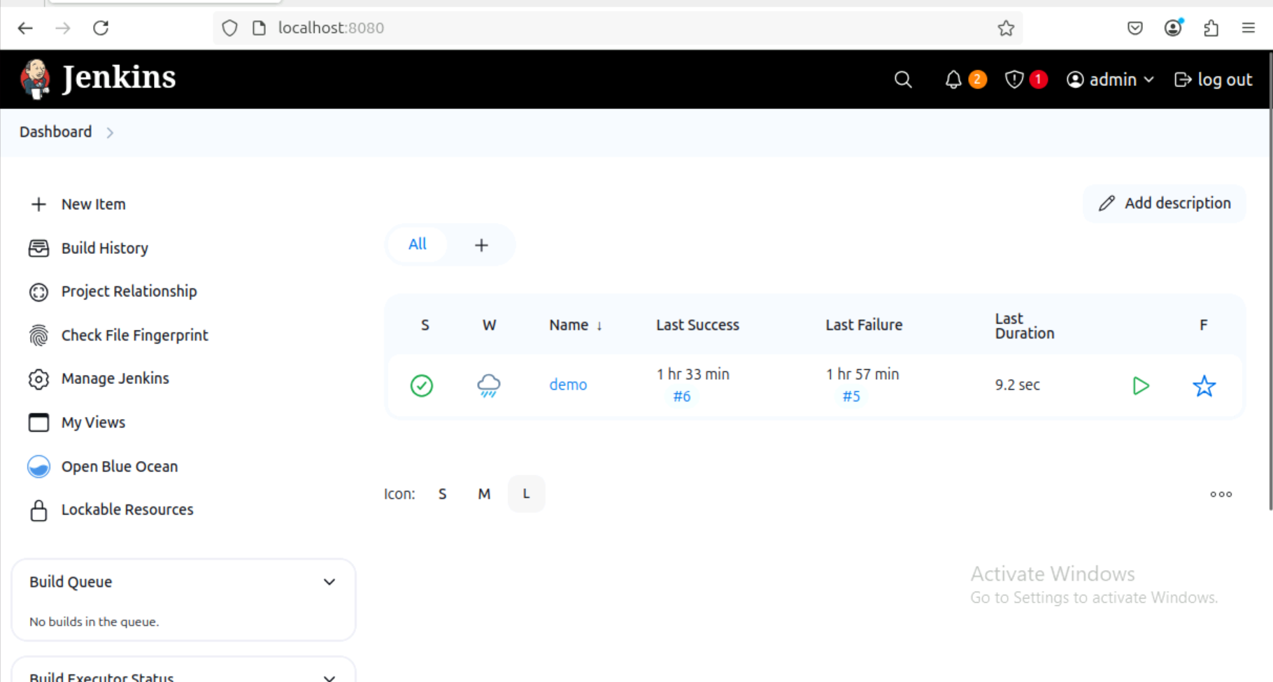
Status of the Pipeline:
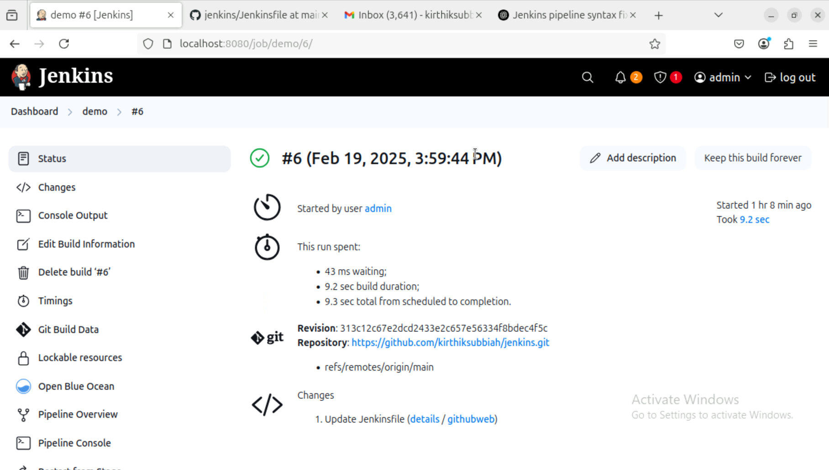

Step 3: Create a Jenkinsfile (CI/CD Pipeline)
In your GitHub repository, create a new file named Jenkinsfile and add the following code:
groovy
CopyEdit
pipeline {
agent any
stages {
stage('Clone Repository') {
steps {
git 'https://github.com/your-username/your-repo.git'
}
}
stage('Build') {
steps {
sh 'echo "Building the application..."'
}
}
stage('Test') {
steps {
sh 'echo "Running tests..."'
}
}
stage('Deploy') {
steps {
sh 'echo "Deploying application..."'
}
}
}
}
Explanation:
- Stage 1: Clone Repository → Pulls the latest code from GitHub.
- Stage 2: Build → Builds the application (placeholder command).
- Stage 3: Test → Runs tests (placeholder command).
- Stage 4: Deploy → Deploys the app (placeholder command).

Step 4: Build and Run the Pipeline
1️. Go back to Jenkins Dashboard → Click on your job.
2️. Click Build Now.
3️. Click Console Output to see the progress.
If everything is successful, you will see all stages completed in the output.

Step 5: Deploy with Docker (Optional)
If you want to deploy your application as a Docker container, modify your Jenkinsfile like this:
groovy
CopyEdit
pipeline {
agent any
environment {
IMAGE_NAME = 'your-dockerhub-username/my-app'
}
stages {
stage('Clone Repository') {
steps {
git 'https://github.com/your-username/your-repo.git'
}
}
stage('Build Docker Image') {
steps {
sh 'docker build -t $IMAGE_NAME .'
}
}
stage('Push Docker Image') {
steps {
withDockerRegistry([credentialsId: 'docker-hub-credentials']) {
sh 'docker push $IMAGE_NAME'
}
}
}
stage('Deploy') {
steps {
sh 'docker run -d -p 8080:80 $IMAGE_NAME'
}
}
}
}
Explanation:
- Builds a Docker image of your application.
- Pushes it to Docker Hub (requires credentials setup in Jenkins).
- Deploys the container on a local machine or server.

- You have successfully set up Jenkins CI/CD to build, test, and deploy a simple app!
- If using Docker, your app is now running on http://localhost:8080.

- Automating a Python Application Build using Jenkins.

Step 1: Install Jenkins and Required Plugins
- Start the Jenkins service and log in to the Jenkins dashboard.
- Navigate to Manage Jenkins → Plugins.
- Install the following plugins:
  - Pipeline Plugin (for defining Jenkins Pipelines)
  - Git Plugin (for pulling code from GitHub)
  - Build Tools Plugin (for executing builds)
- Restart Jenkins to apply the changes.

Step 2: Create a New Jenkins Job
- Open Jenkins Dashboard.
- Click on New Item → Enter a project name.
- Choose Freestyle Project or Pipeline Project.
- Click OK to create the project.
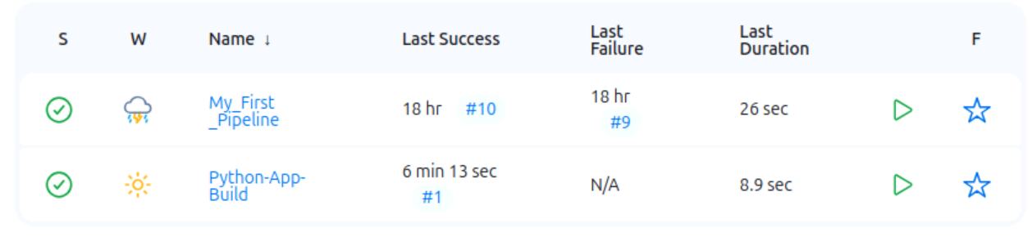
Step 3: Configure Jenkins to Pull Code from GitHub
- Open the newly created Jenkins job.
- Navigate to Source Code Management.
- Select Git and enter the repository URL:
  - Example: https://github.com/your-repo/python-app.git
- Configure GitHub credentials if authentication is required.

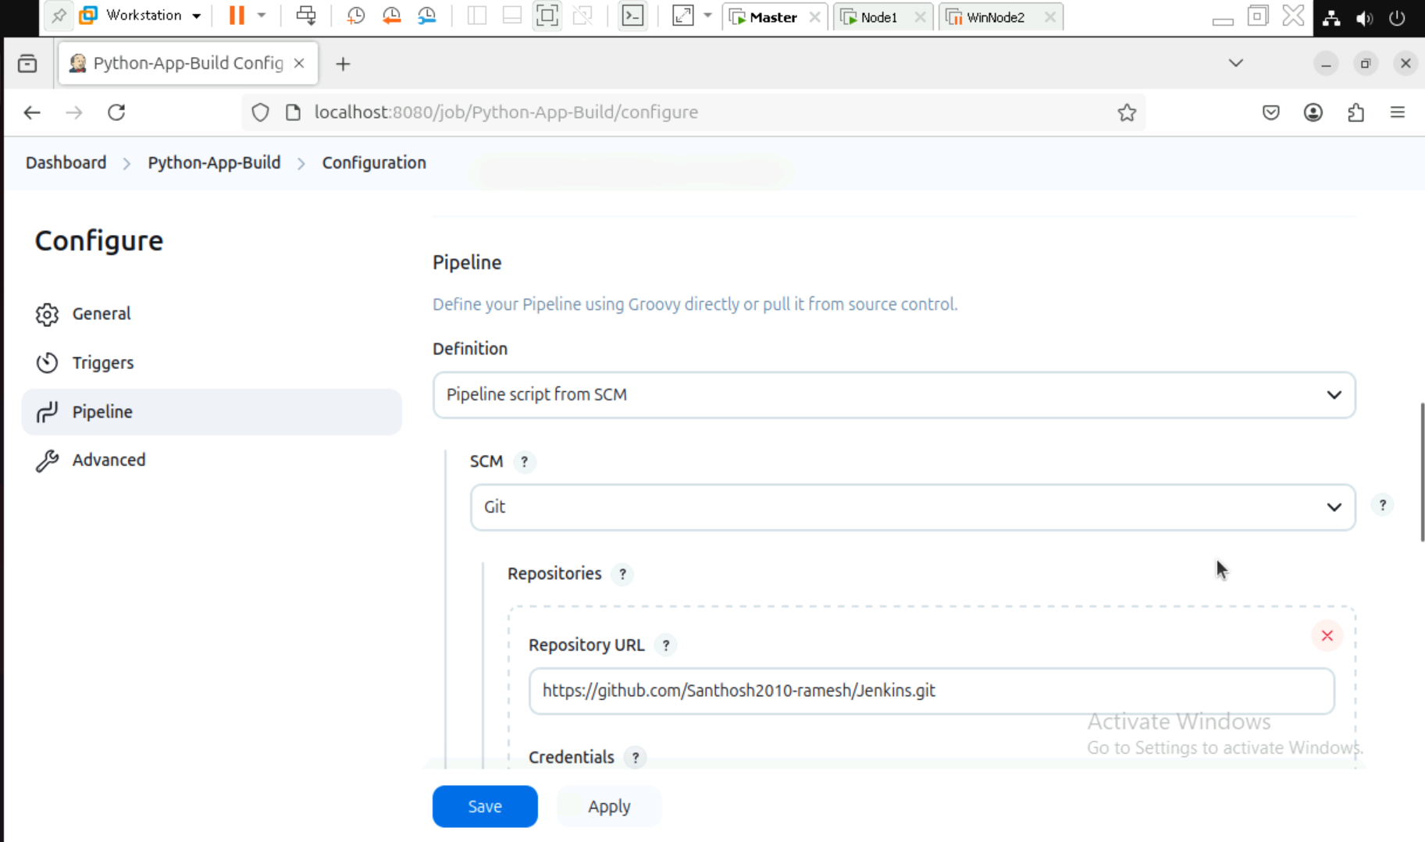
Step 4: Install Dependencies and Run Tests
Step 1: Adding the desired branch here we use Main branch.
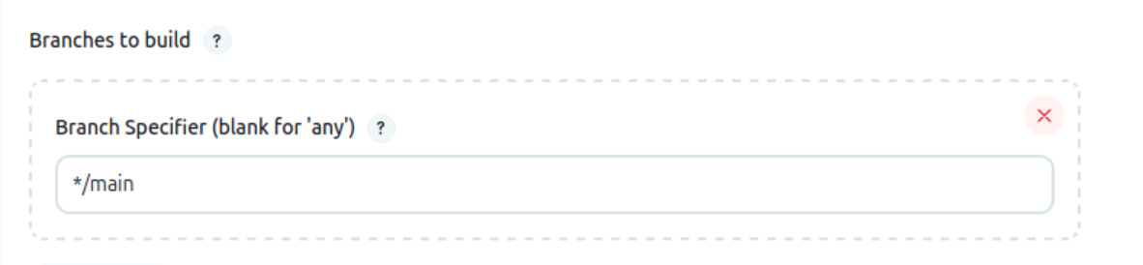
Step 5: Pipeline with Python Scripts.
Step 1: Building the Declarative: Checkout SCM with the Script.
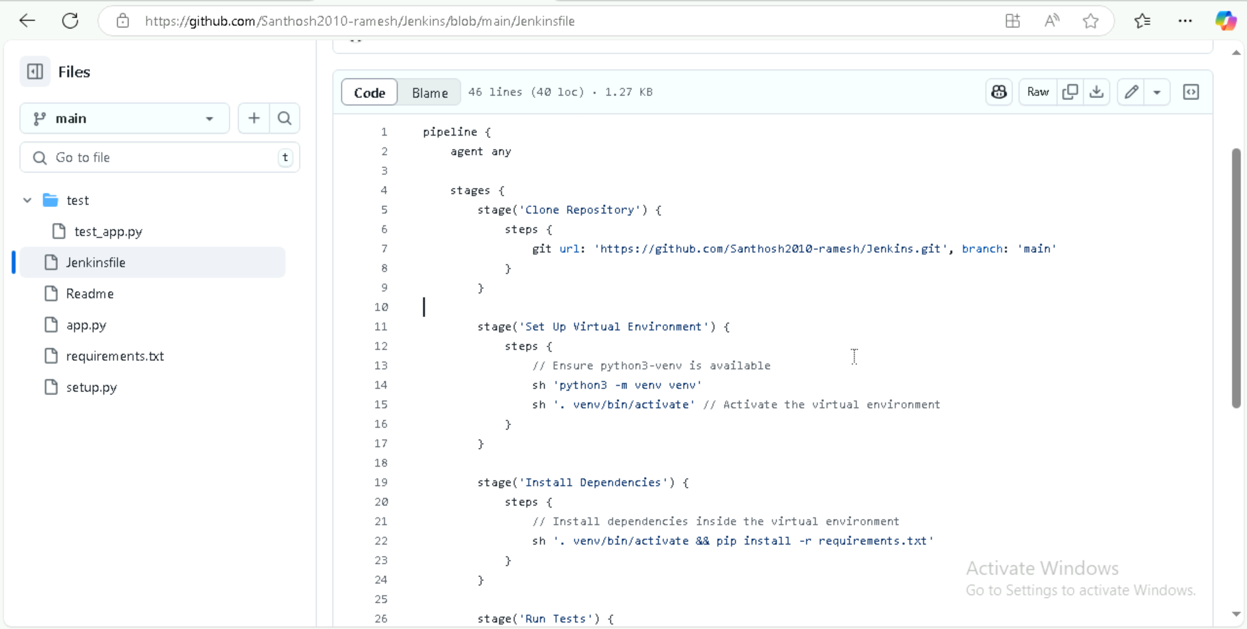
Step 2: Sample Python file.
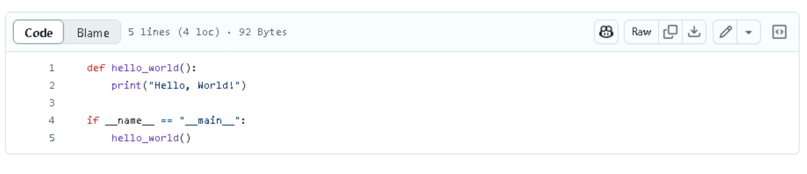
Step 3: Creating Requirements.txt file.
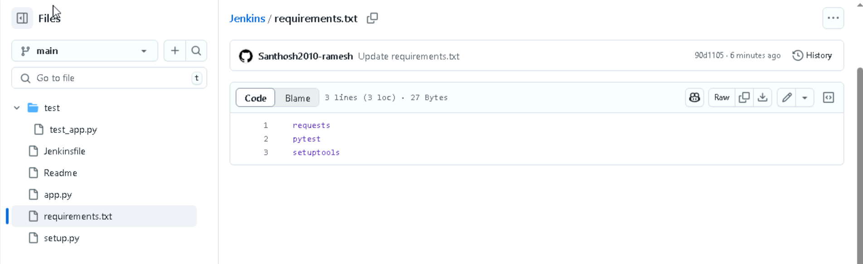
Step 4: Creating a Setup.py file.
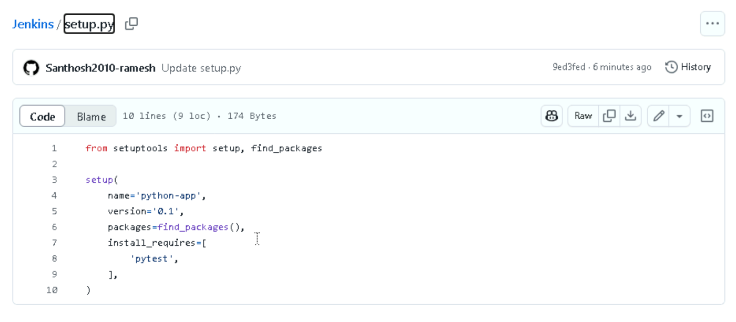

Step 5: Creating a sample test.py for checkrun.
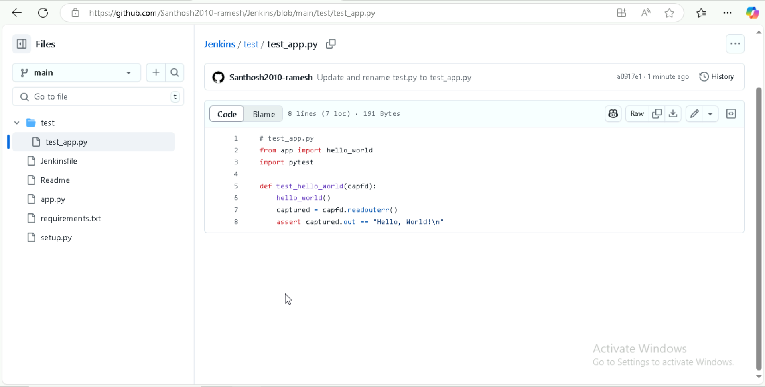
Step 6: Build and Archive Artifacts with Declarative: Checkout SCM, Clone Repository, set up Virtual Environment, Install Dependencies, Run Tests, Build Artifact, Archive Artifact.
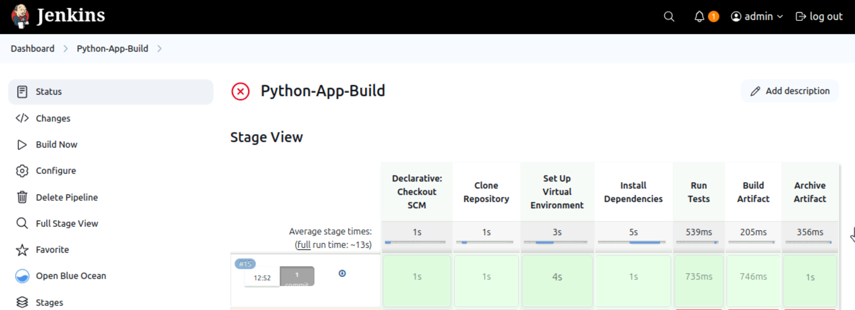

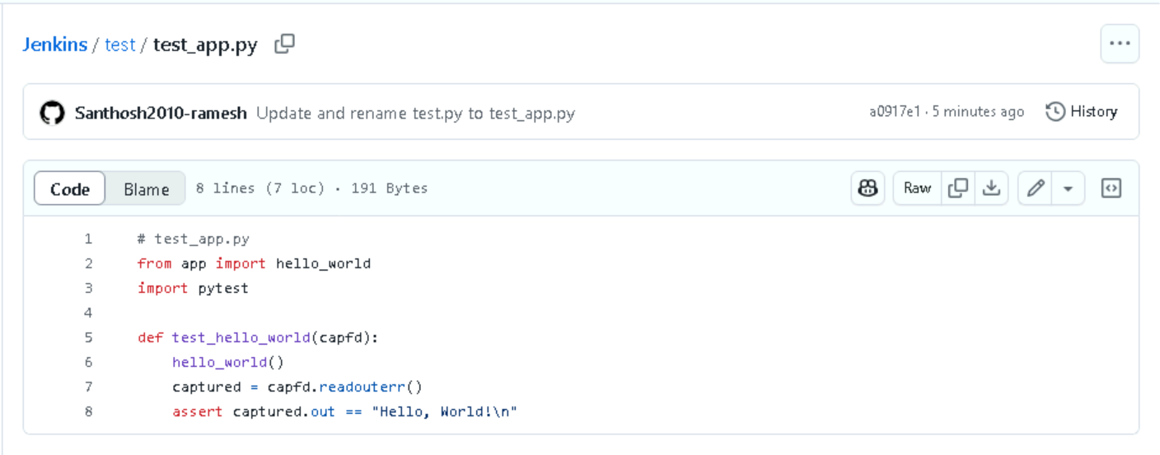

Step 7: Run the Jenkins Job
- Click Build Now to trigger a build.
- Monitor logs in Console Output.

